2.1

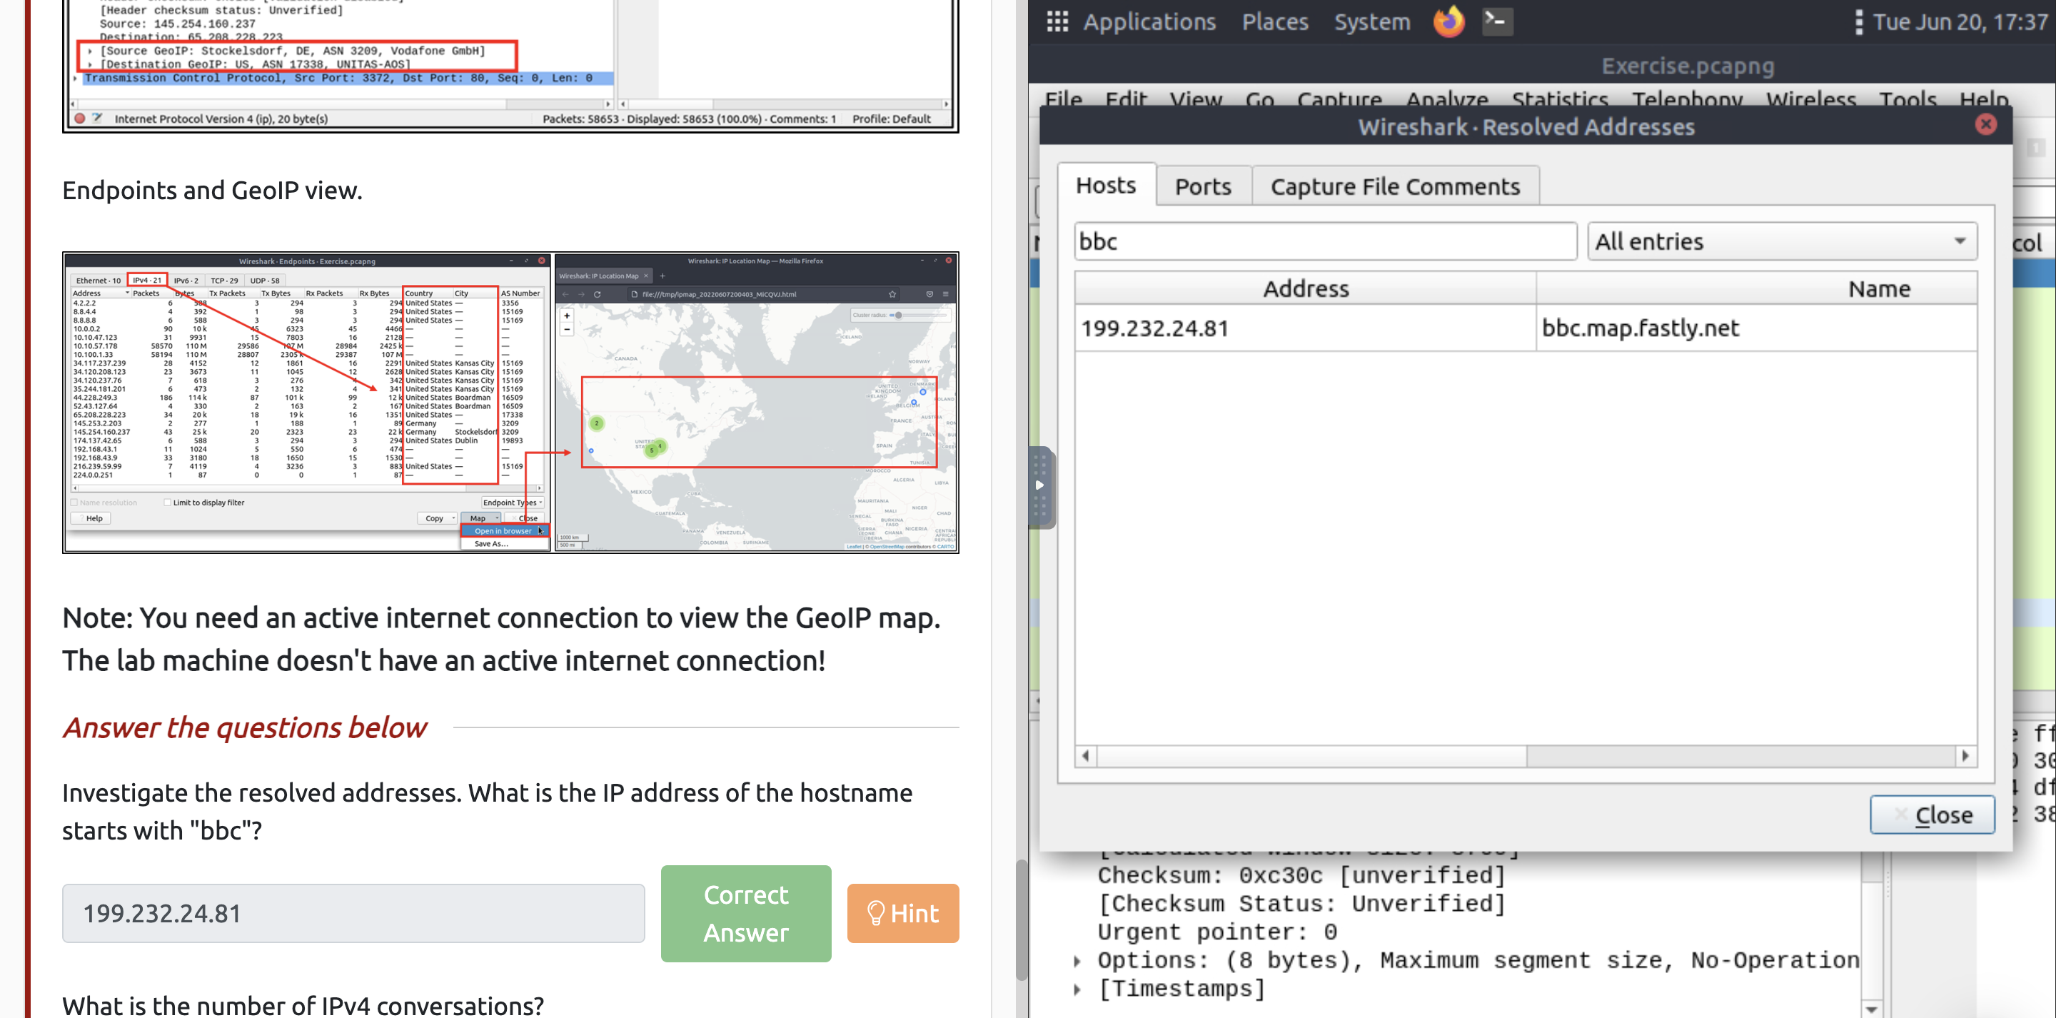

2.2

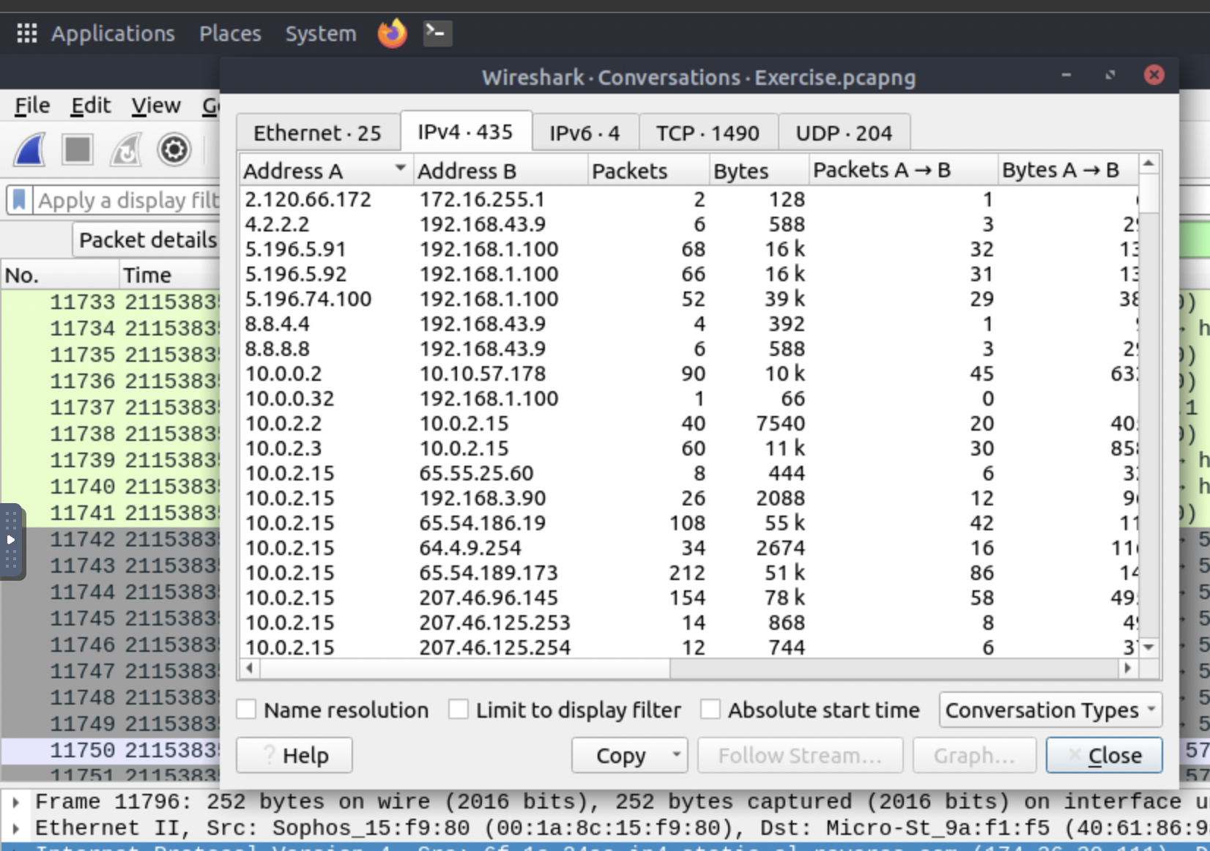

2.3

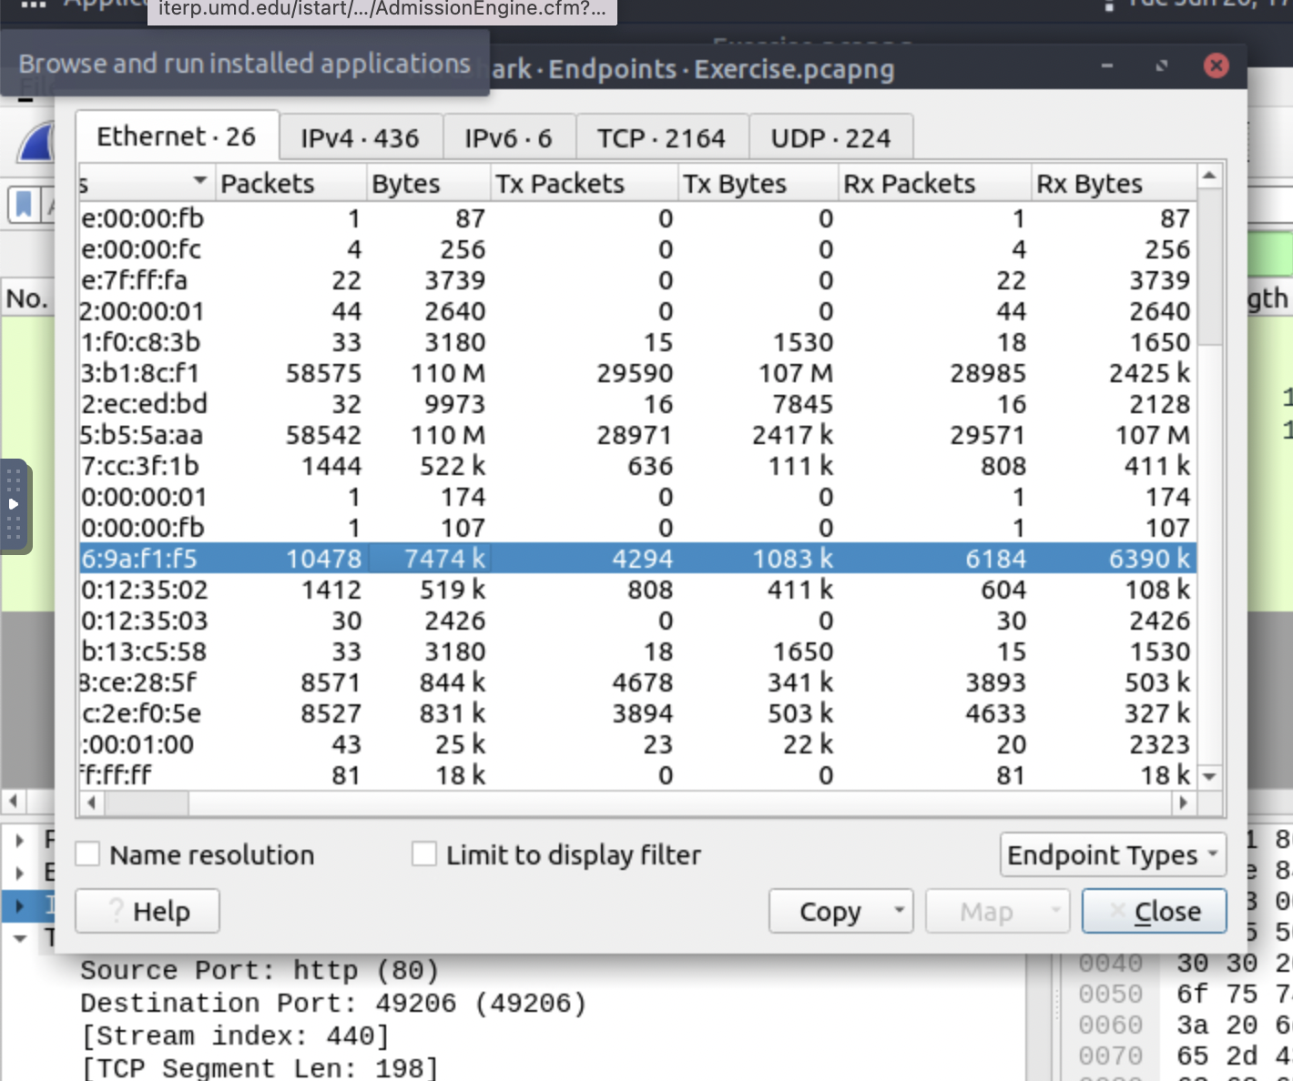

2.4

Count the number of Kansas City in the statics. - > endpoits

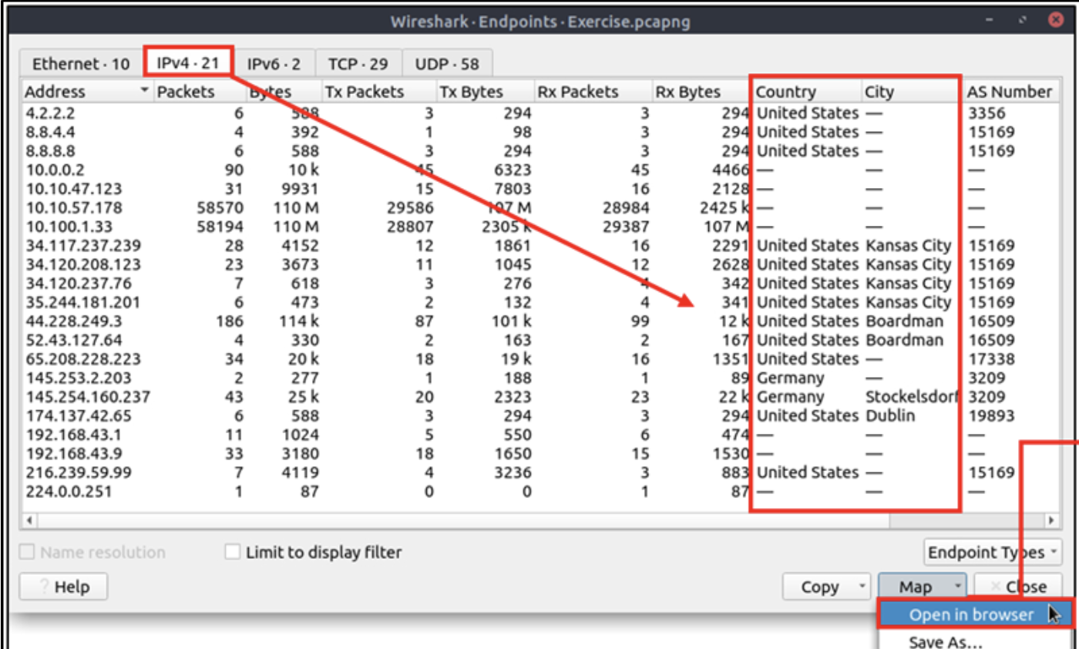

2.5

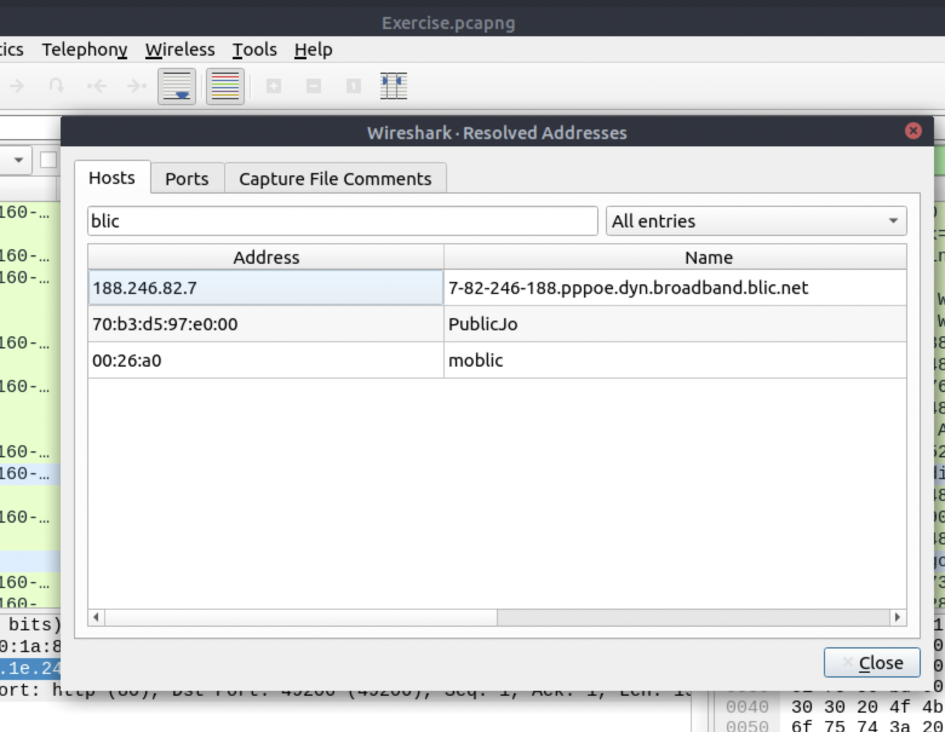

Task3:

3.1

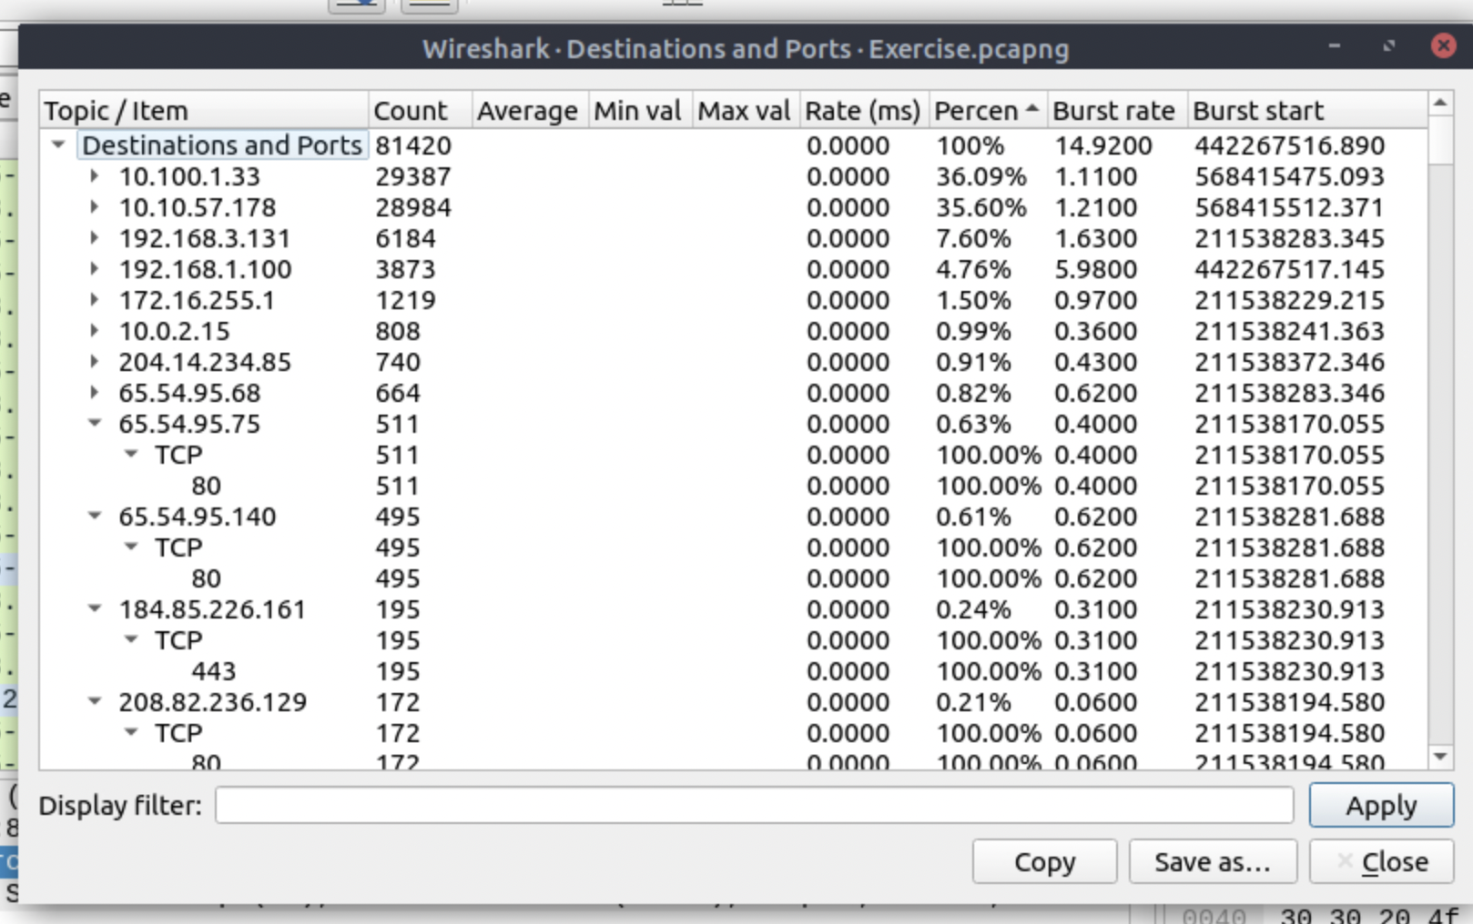

3.2

Found in statics -> DNS

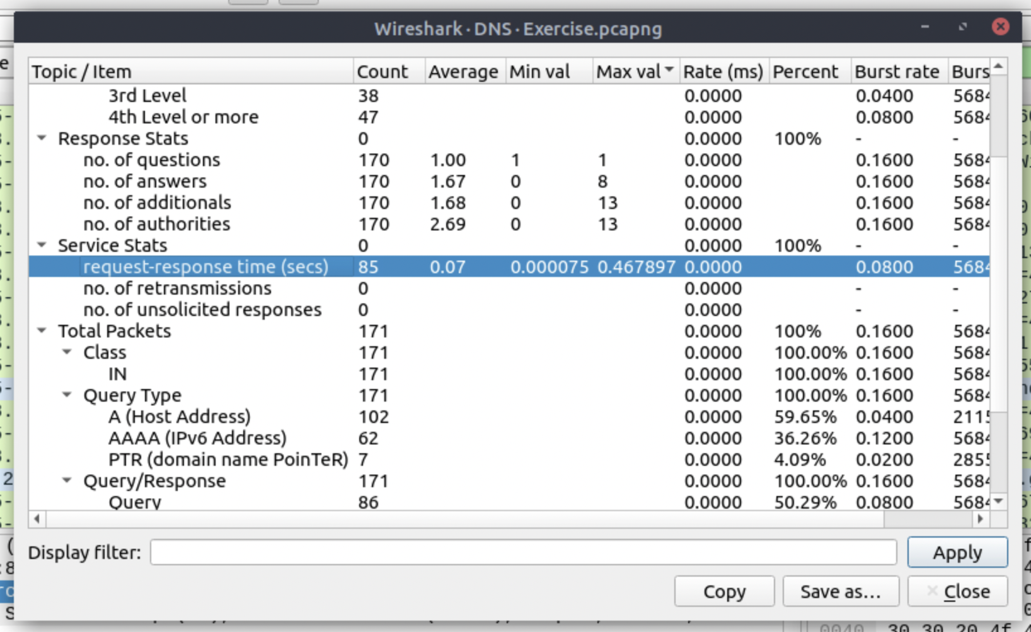

3.3

Statics -> HTTP look for rad.msn.com gives count as 39

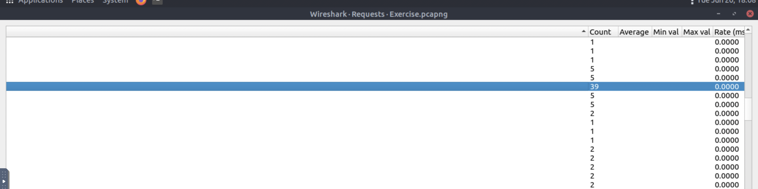

Task5

5.1

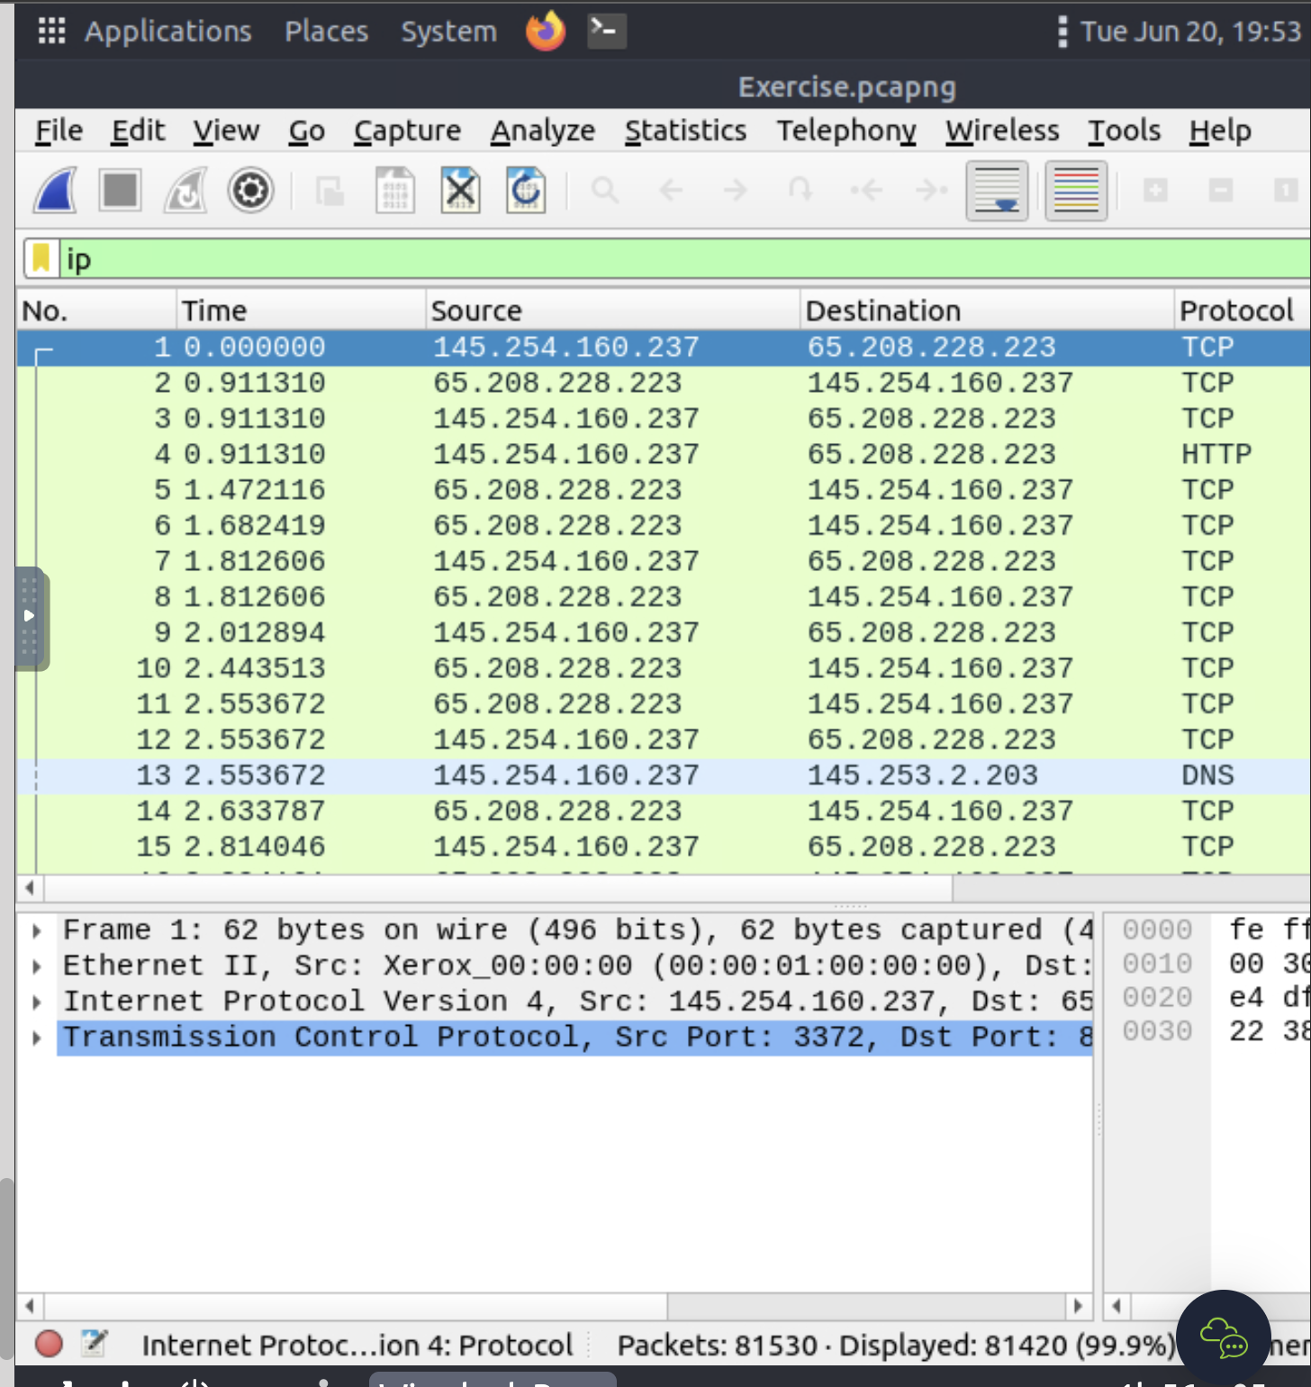

5.2

With filter ip.ttl<10 gives answer 66

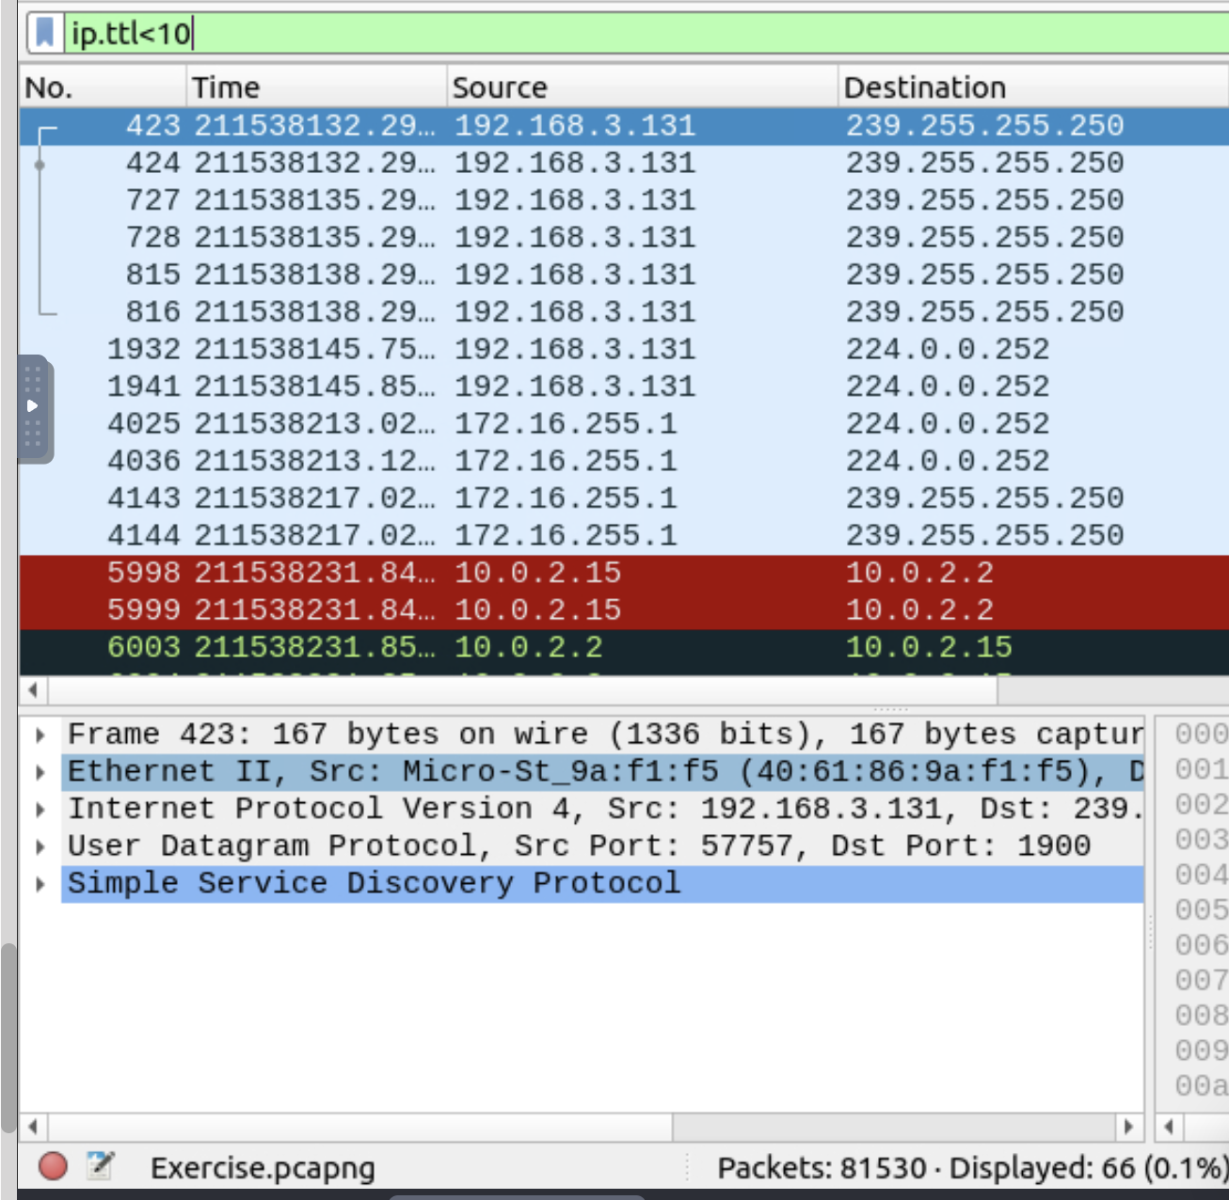

5.3

With filter tcp.port==4444 gives answer:632

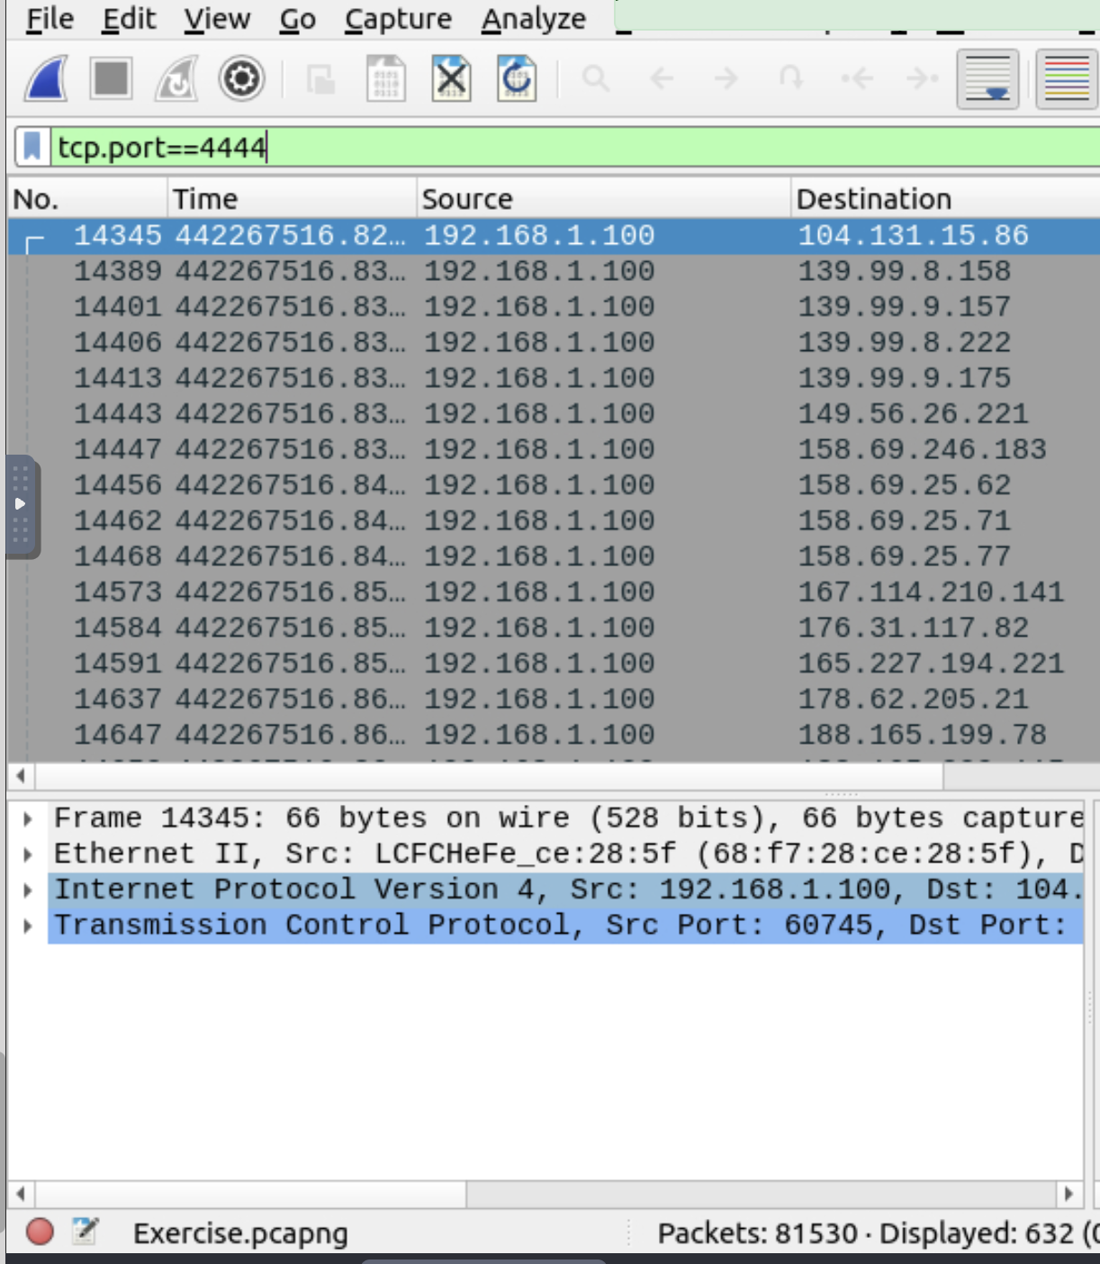

5.4

Filter: http.request.method==”GET” && tcp.port==80 gives answer 527

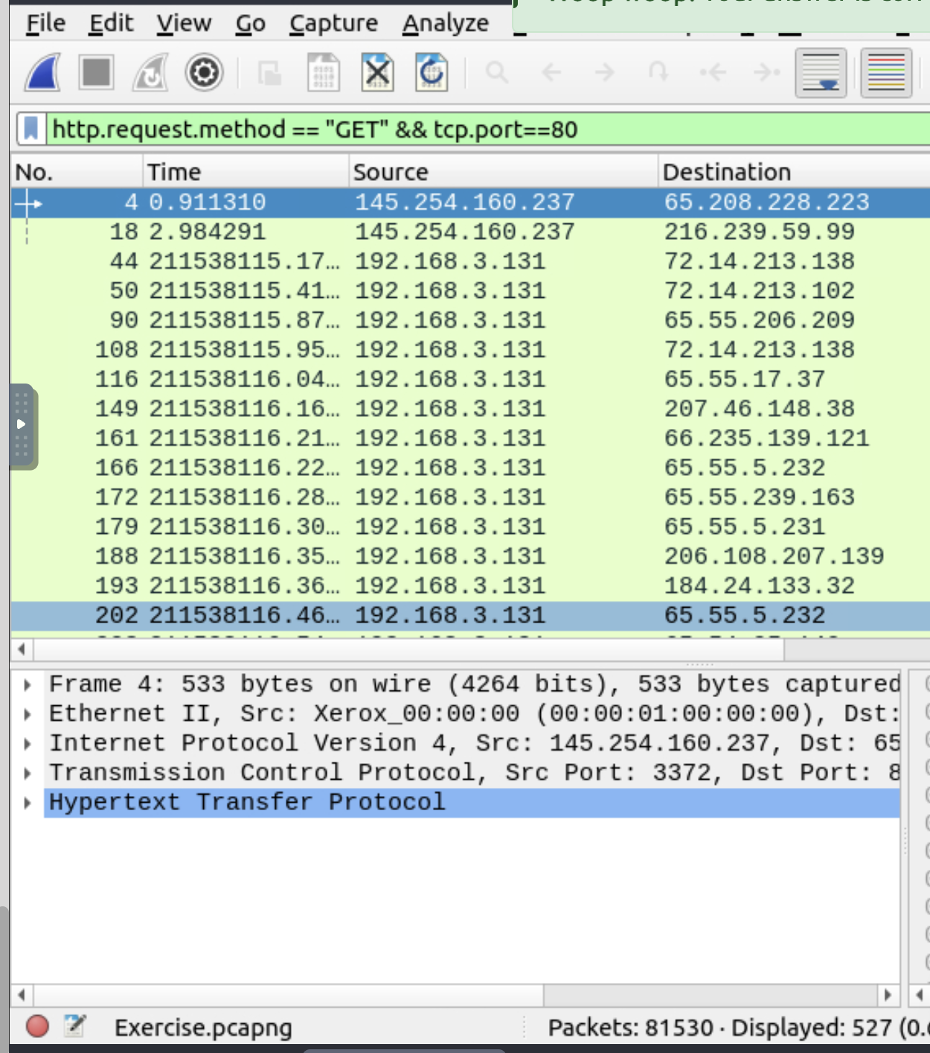

5.5

Statics - > DNS. Apply filter dns.flags.response==0 and looks for type A

Gives answer:51

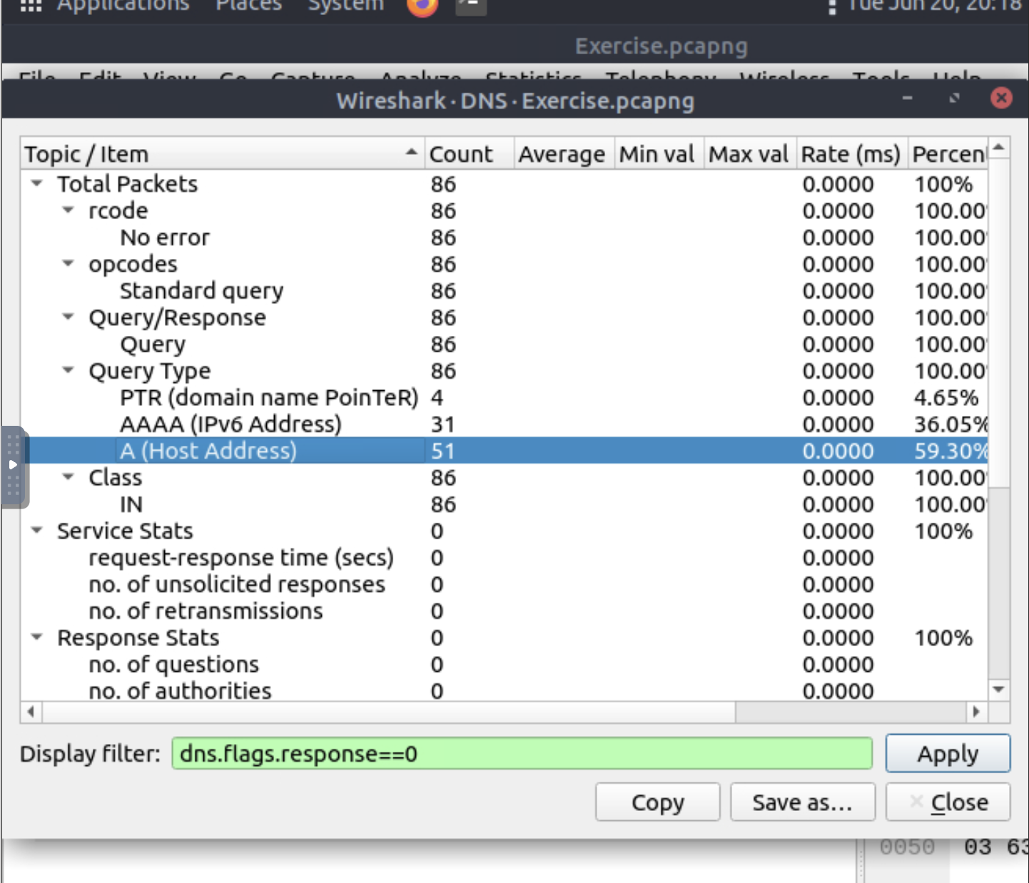

Task6

6.1

With filter http.server contains “Microsoft” and !tcp.port==80 gives answer 21

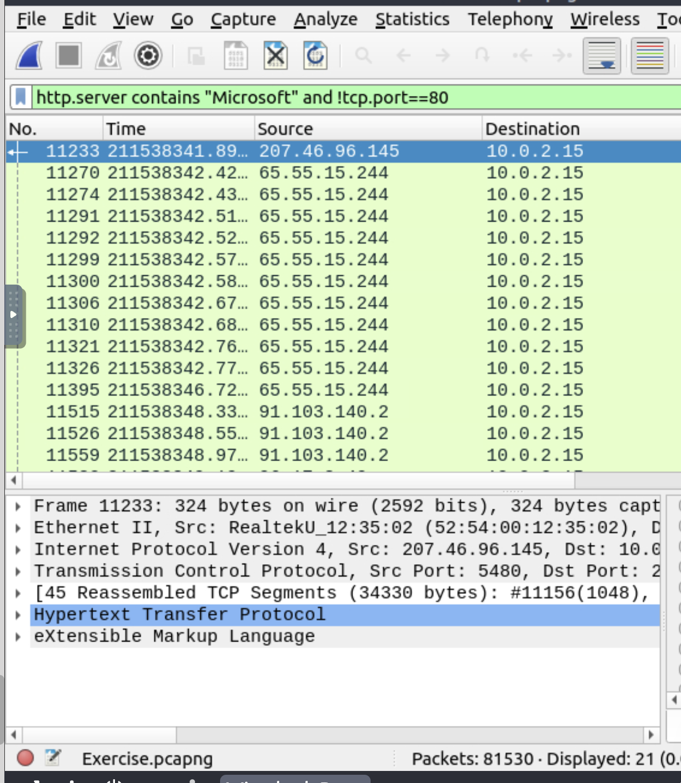

6.2

With filter http.server ==”Microsoft-IIS/7.5” gives answer 71

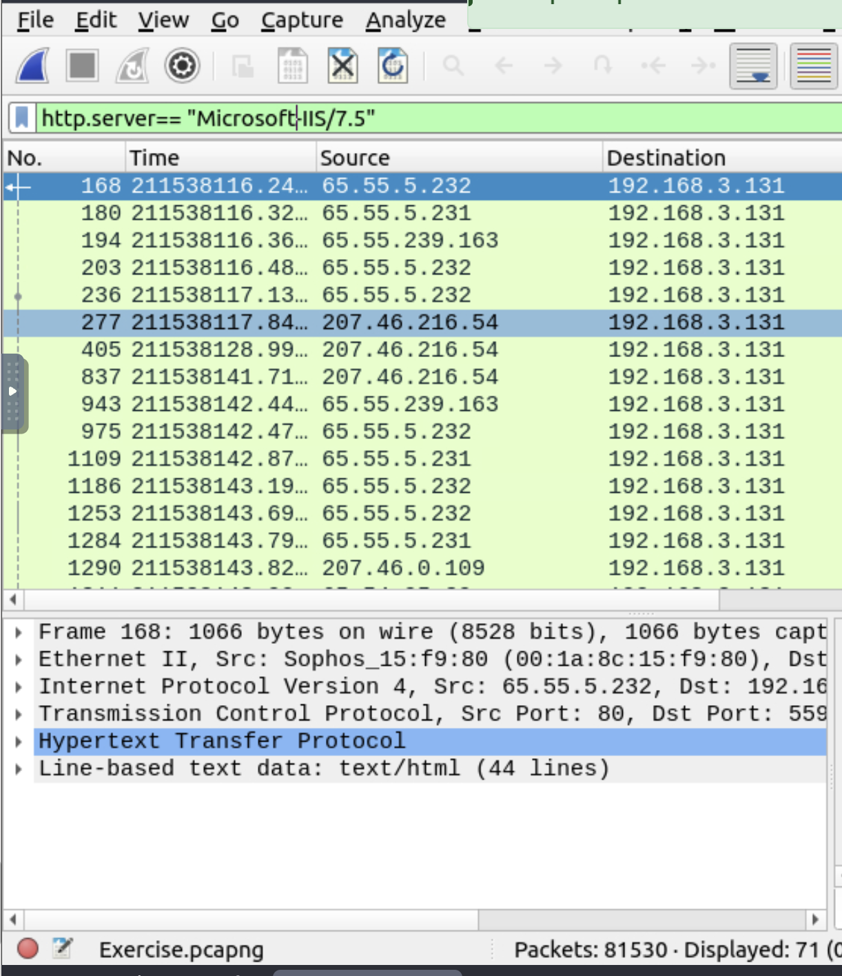

6.3

With filter tcp.port in {3333 4444 9999} gives answer 2235

